Activity 5.5: Meet the Potato Heads
Meet the Potato Heads:
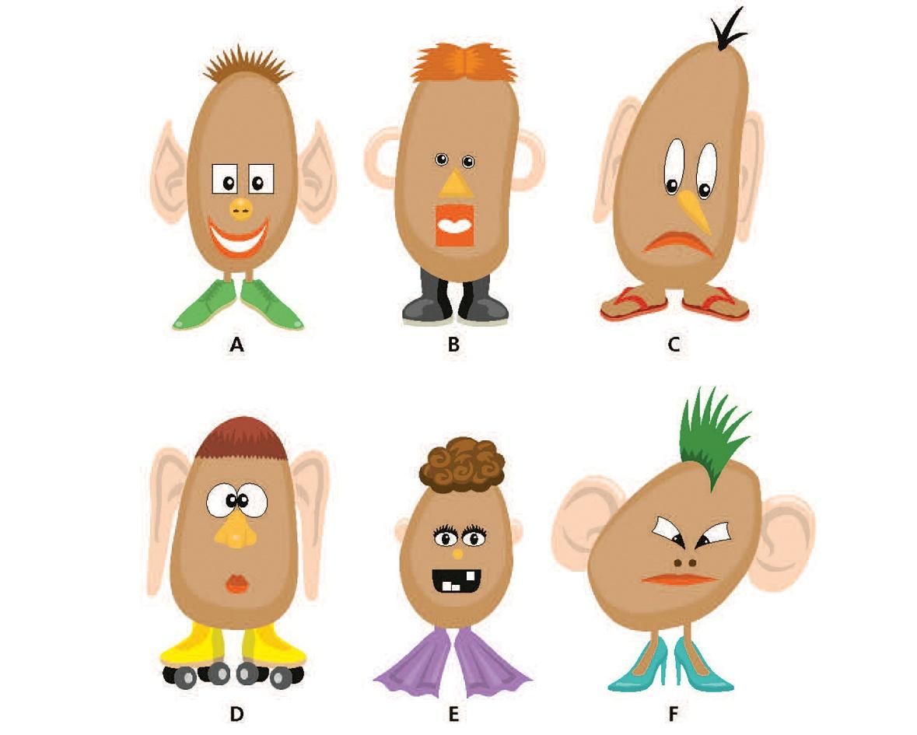
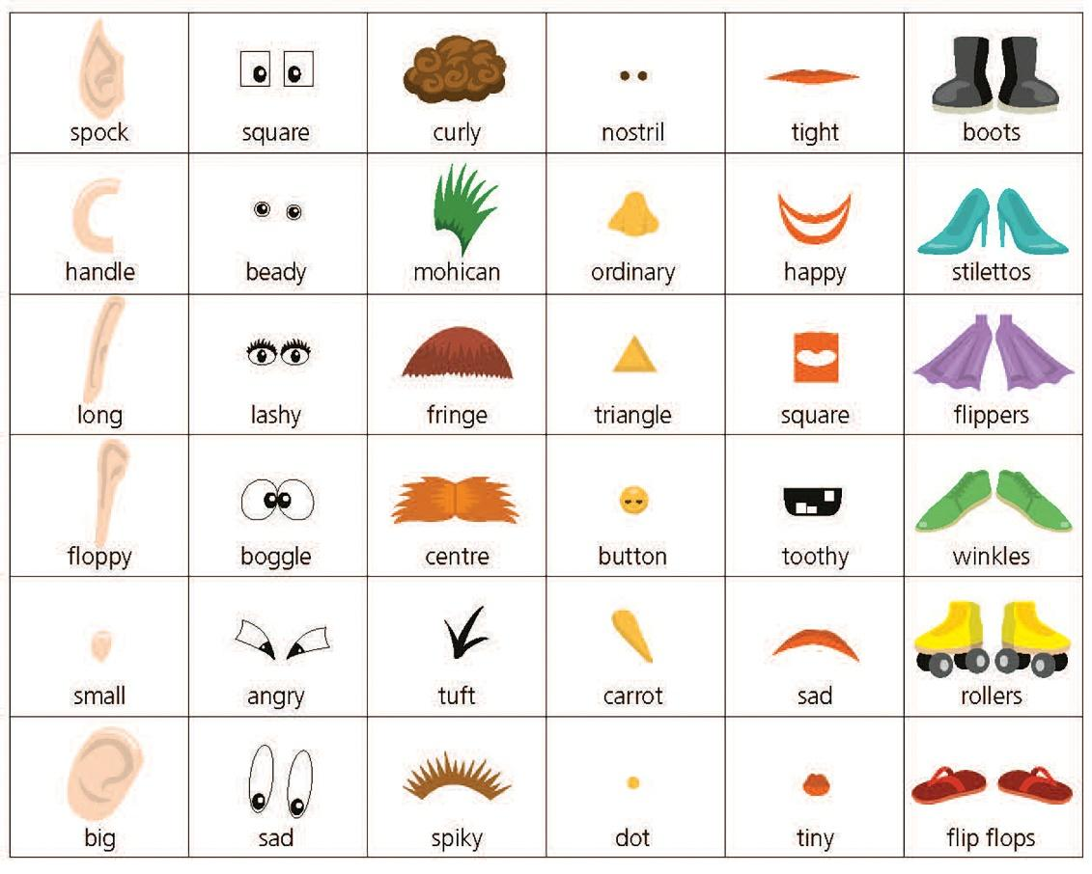

- a) Decompose Potato Head B, listing all the elements making up the head. (2 marks)
b) Explain the purpose of decomposition in computational thinking. (3 marks)

- a) Describe the pattern that has been used to build all of the heads. (2 marks)

b) What do we call this cornerstone of computational thinking? (1 mark)

- a) Which elements in the list below could be ignored if we wanted to develop a Potato Head building algorithm? Cross out the ones that could be ignored. (3 marks)
feet colour of items size of potato
hair shape of potato nose
eyes type of potato mouth
age of potato ears

b) What do we call the cornerstone of computational thinking involving removing unhelpful detail? (1 mark)

- a) Use standard flow diagram symbols to draw a flow diagram for a Potato Head building algorithm. The algorithm should enable you to make any potato head, with adding feet optional. (4 marks)

b) Write out a text algorithm for building Potato Head D, with adding ears optional. (4 marks)

